**ASSIGNMENT 1 FRONT SHEET**

|  |  |  |  |
| --- | --- | --- | --- |
| **Qualification** | **BTEC Level 5 HND Diploma in Computing** | | |
| **Unit number and title** | Unit 16: Cloud computing | | |
| **Submission date** |  | **Date Received 1st submission** |  |
| **Re-submission Date** |  | **Date Received 2nd submission** |  |
| **Student Name** | PHAN MINH TRI | **Student ID** | GCC18015 |
| **Class** | SU20-GCC0701-1644 | **Assessor name** | THAI MINH TUAN |
| **Student declaration**  I certify that the assignment submission is entirely my own work and I fully understand the consequences of plagiarism. I understand that making a false declaration is a form of malpractice. | | | |
|  |  | **Student’s signature** | TRI |

**Grading grid**

|  |  |  |  |  |  |  |
| --- | --- | --- | --- | --- | --- | --- |
| P1 | P2 | P3 | P4 | M1 | M2 | D1 |
|  |  |  |  |  |  |  |

|  |  |  |
| --- | --- | --- |
| **❒ Summative Feedback: ❒ Resubmission Feedback:** | | |
| **Grade:** | **Assessor Signature:** | **Date:** |
| **Signature & Date:** | | |

**ASSIGNMENT 1 BRIEF**

|  |  |  |  |
| --- | --- | --- | --- |
| **Qualification** | **BTEC Level 5 HND Diploma in Computing** | | |
| **Unit number** | Unit 16: Cloud computing | | |
| **Assignment title** | Cloud Computing Solutions | | |
| **Academic Year** | 2019 – 2020 | | |
| **Unit Tutor** | DO Quoc Binh | | |
| **Issue date** |  | **Submission date** |  |
| **IV name and date** |  | | |

|  |
| --- |
| **Submission Format:** |
| *Format:* The submission is in the form of 1 document  You must use font *Calibri size 12, set number of the pages and use multiple line spacing at 1.3. Margins must be: left: 1.25 cm; right: 1 cm; top: 1 cm and bottom: 1 cm.* The reference follows Harvard referencing system.  *Submission:* Students are compulsory to submit the assignment in due date and in a way requested by the Tutors. The form of submission will be a soft copy posted on <http://cms.greenwich.edu.vn/>  *Note:* The Assignment *must* be your own work, and not copied by or from another student or from  books etc. If you use ideas, quotes or data (such as diagrams) from books, journals or other sources, you must reference your sources, using the Harvard style. Make sure that you know how to reference properly, and that understand the guidelines on plagiarism. *If you do not, you definitely get failed* |
| **Unit Learning Outcomes:** |
| **LO1** Demonstrate an understanding of the fundamentals of Cloud Computing and its architectures.  **LO2** Evaluate the deployment models, service models and technological drivers of Cloud Computing and validate their use. |
| **Assignment Brief and Guidance:** |
| Scenario  ATN is a Vietnamese company which is selling toys to teenagers in many provinces all over Vietnam. The company has the revenue over 500.000 dollars/year. Currently each shop has its own database to store transactions for that shop only. Each shop has to send the sale data to the board director monthly and the board director need lots of time to summarize the data collected from all the shops. Besides the board can’t see the stock information update in real time.  The table of contents in your technical report should be as follows:   1. Explain to the board director the fundamentals of cloud computing and how it is popular nowadays (500 words) 2. Persuade the board director to use Cloud Computing in ATN (300 words) 3. Proposed solution (higher level solution description – around 200 words). 4. Explain the appropriateness of the solution for the scenario (350 words with images and diagrams). 5. Architectural design (architectural diagram and description). 6. Detailed design:    1. Deployment model (discussion on why that model was chosen).    2. Service model (discussion on why that model was chosen).    3. Programming language/web server/database server chosen. 7. Summary. |

|  |  |  |
| --- | --- | --- |
| Learning Outcomes and Assessment Criteria | | |
| Pass | Merit | Distinction |
| **LO1** Demonstrate an understanding of the fundamentals of Cloud Computing and its architectures | | **LO1 & 2**  **D1** Justify the tools chosen to realise a Cloud Computing solution. |
| **P1** Analyse the evolution and fundamental concepts of Cloud Computing.  **P2** Design an appropriate architectural Cloud Computing framework for a given scenario. | **M1** Discuss why an organisation should migrate to a Cloud Computing solution. |
| **LO2** Evaluate the deployment models, service models and technological drivers of Cloud Computing and validate their use | |
| **P3** Define an appropriate deployment model for a given scenario.  **P4** Compare the service models for choosing an adequate model for a given scenario. | **M2** Demonstrate these deployment models with real world examples. |

Contents

P1 Analyse the evolution and fundamental concepts of Cloud Computing.(1,2) **Error! Bookmark not defined.**

P2 Design an appropriate architectural Cloud Computing framework for a given scenario. **Error! Bookmark not defined.**

P3 Define an appropriate deployment model for a given scenario. **Error! Bookmark not defined.**

P4 Compare the service models for choosing an adequate model for a given scenario. **Error! Bookmark not defined.**

**P1 Analyse the evolution and fundamental concepts of Cloud Computing.**

* Introduction

Cloud computing is a model for providing centralized, accessible on-demand network access to a shared pool of configurable computing resources (e.g. networks, devices, data, applications, and services) that can be efficiently dispersed and applied with minimal maintenance intervention or participation of service providers. The cloud infrastructure comprises 5 core components, 3 implementation models, and 4 distribution models.

Computing, also known as Virtual Database Computing, is a technological paradigm focused on information technology and the growth of the Internet. The term "cloud" here is a metaphor for the Internet (based on its layout in a computer network diagram) and as an association of the complexity of its contained infrastructures.

Cloud storage is an integral approach delivering IT as a software. It is an Internet-based networking system that offers common services such as the delivery of power over the grid. The cloud machines are designed to operate together, and the combined processing capacity is utilized by different programs, as though they were operating on one machine. Flexibility in cloud infrastructure is a feature of on-demand distribution of services. It makes the usage of accrued device capital simpler and negates the need to delegate unique equipment to a mission. Web pages and server-based applications had been executed on a particular system prior to cloud computing. The introduction of cloud storage allows use of tools as a virtual computer. This single architecture offers an atmosphere where programs are operating separately, unaware of any individual architecture.

* **How does the cloud work?**

Cloud computing allows users to access services such as servers, data and the Internet. It operates, controls and retains a network link through the cloud service provider. In the meanwhile, the online site should support consumers and use what they want.

* **The development of cloud computing today:**

Data management has already become a necessity in all areas. Over the last 20 years, the usage of smartphones and tablets has expanded exponentially. All large and small enterprises depend on data that need low cost, accessible storage.

Although only been in development for a very short time.. But cloud infrastructure today is very popular. Maybe a lot of applications , high-tech software (smart phones, tablets, laptops) that we're using have cloud computing programs that we don't notice. The cloud infrastructure systems we see the most today are:

* iCloud of Iphone
* Google Driver
* There are several reasons why the cloud becomes the new popular IT trend:
* Reduced costs: Cloud computing can reduce both capital costs (CAPEX) and operating costs (OPEX), as resources are purchased only when needed and only paid for when used.
* Streamlined employee usage: Using the cloud unleashes valuable staff allowing them to focus on delivering value rather than maintaining hardware and software.
* Flexible scalability: Cloud computing allows the ability to instantly scale, or increase or decrease at any time without the need for a long-term commitment.
* The benefits of cloud computing:
* Fast

The cloud gives people easy access to a variety of technologies that can innovate faster and develop almost anything human could imagine. People can quickly gather resources as needed - from infrastructure services, like computing, storage, and databases, to the Internet of Things, machine learning, data warehouses, and analytics, etc.

People can deploy technology services quickly and move from concept to completion several levels of intensity faster than before. This gives people the freedom to experiment, test new ideas to differentiate customer experience from business transformation.

* Flexible scale

With cloud computing, users do not have to overly provision resources to handle future peak business operations. Instead, users provide the number of resources they need. These resources can be scaled up or down instantly to increase and decrease capacity as the user's business needs change.

* Costs avoided

The cloud infrastructure helps customers to substitute fixed costs with variable costs (data centers, physical storage, etc.) and just compensation for the services that consumers need. Moreover, owing to economies of scale the production costs would still be even smaller than their own.

* Deploy globally in minutes

Users can expand to new geographic areas with the cloud, and roll out in minutes globally. AWS, for example, provides a nationwide network, and customers can install their software in only a few clicks in specific locations. Placing devices near to the end-user reduces latency and increases the experience.[1]

* **Cloud ecosystem:**
* The cloud ecosystem is a dynamic network of interdependent elements that all function together to deliver cloud services. Enterprise cloud computing has typically been conceived of in three specific business areas – infrastructure-as-a-service (IaaS ), platform-as-a-service (PaaS ), and software-as-a-service ( SaaS).
* While the exact benefits that vary based on the cloud services utilized, the usage of a cloud service typically means that businesses do not have to buy or maintain their own data systems:
* ATN businesses that are experienced in operating and managing these services are likely to have better experience and more skilled staff than a small company might manage to hire, so cloud vendors can have a more secure and efficient network for consumers.
* For ATN company with a high usage application, such as an app that is only used at a specific time of the week or year, leaving that app in the cloud could be possible, financial implications instead of placing specialized hardware and software.
* For ATN company, the only thing a user's computer needs to be able to run the software is an interface to use the cloud computing system, which can be simply a Web browser, and the cloud network will take over the rest.
* No longer hire a computer, update programs or operating systems, or shut down and maintain hardware or devices, since it is on the vendor's side.
* Instead of running an e-mail program on your computer, we are log in to an e-mail account over the internet remotely. The software and storage for our account don't exist on computer - it is on the server's cloud computer.
* One benefit of utilizing cloud storage platforms is that companies may eliminate the initial expense and difficulty of buying and running their own IT networks and then only pay for what they need when they use it.

**P2 Design an appropriate architectural Cloud Computing framework for a given scenario.**

* ATN is a toy company with branches in many other locations and in trouble managing the sales of the stores.

The site side should be put on the cloud to guarantee the maintenance and sales control of each shop, so that users can manage all stores in various regions. Yet there are two important users here are: staff and management:

* Employees can manage products and types of products. Each salesperson in different sales areas will be provided with different login accounts so that management can manage employees.
* Managers can manage employees anywhere at any time, just equipment with network connection.

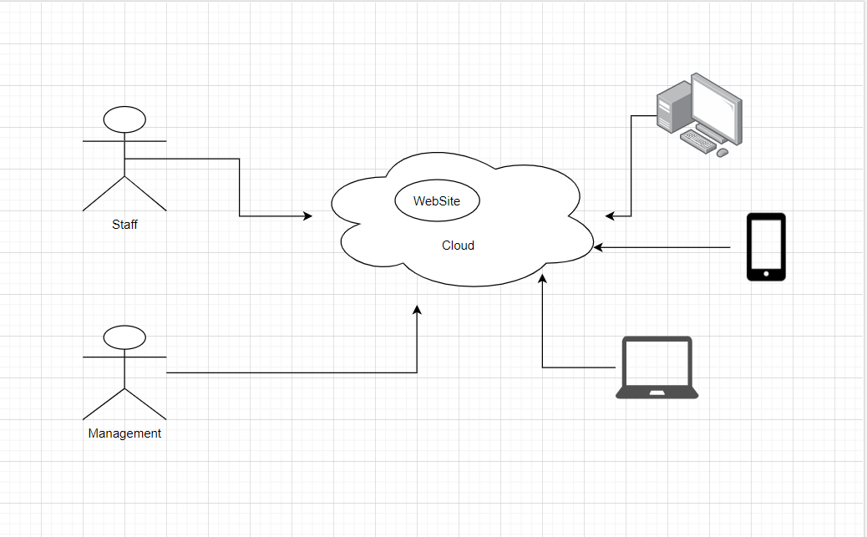

* Use Case Diagram

Provide a Use Case diagram, which describes the requirements that the system must fulfill:

* For employees who want to view products, there is no need to log in and when the employee collects the sales, they must log in with the staff's account.
* For Administrators, when logged in, they can add, edit, and delete products, categories. It is clearly shown in the figure :

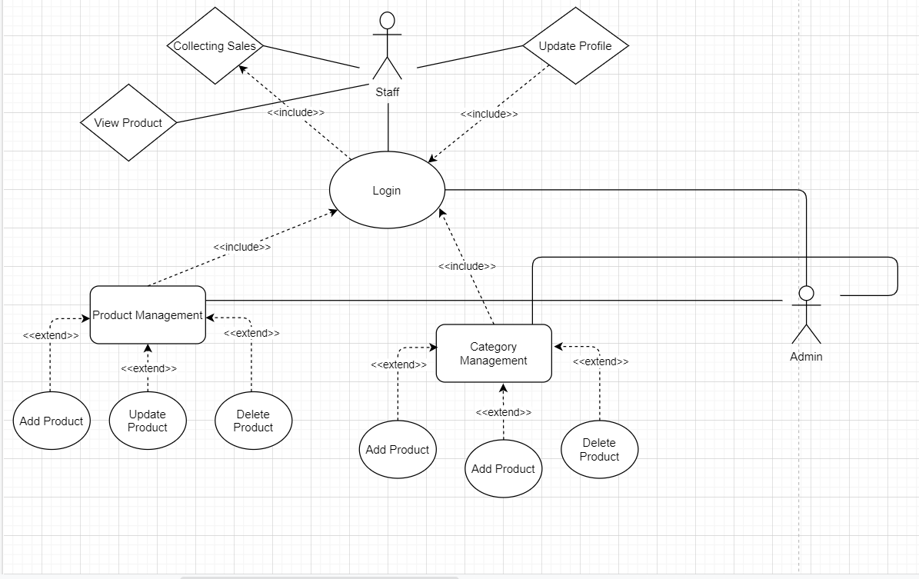

**P3 Define an appropriate deployment model for a given scenario.**

* Cloud Computing Model

Cloud resources in a number of forms may be coordinated or delivered. The method of delivery is based on the client company's criteria. The deployment model specifies cloud utilization and also sets the access cap. The NIST definition refers to public, private, and hybrid deployments to four different delivery types. Both clouds come into one of these four groups.

* **Public clouds** are the most popular way to implement cloud computing. Database services (such as servers and storage) are managed and controlled by a third-party cloud service company and distributed over the Internet. The public cloud deployment model provides the widest range of access to consumers among all cloud deployments. Anyone that subscribes to this would have free access to this cloud service. The client can be either an actual person or a community of users comprising an entity o an enterprise. [2]

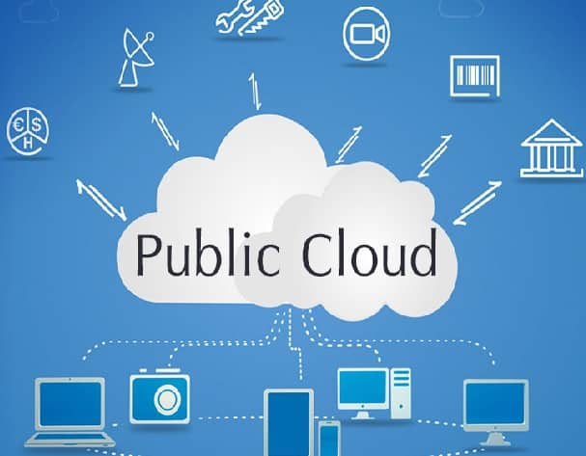

* **The private cloud** consists of computer services utilized solely by a particular corporation or organization. The private cloud will be either housed at the on-site data center of the company or operated by a third-party service provider. However, with a private cloud, utilities and resources are often managed on a private network, and equipment and applications are devoted exclusively to the company.[2]

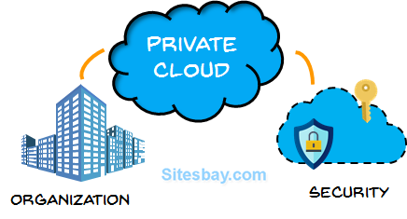

* **Hybrid clouds** merge on-site networks or private clouds with public clouds so that companies can enjoy the advantages of both. In the hybrid cloud, data and software will switch between private and public clouds with greater versatility and further delivery choices. [2]

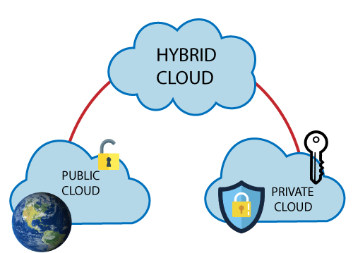

* **The Community Cloud Deployment Model** offers access to a number of community oriented organizations or customers, and the design is designed to achieve a common and special purpose. This is to the advantage of a group of individuals or organizations that have shared issues concerning company efficiency, standards of protection, etc. This model enables the sharing of technology and services by multiple customers belonging to a common group to become cheaper than a private cloud.
* Deployment model to suit company
* Using the **public cloud** can save the business money, don't need to purchase equipment or applications, just pay for the technology we use.
* Therefore, we will not require repair, because the service provider would maintain it.
* The facilities are almost limitless in terms of scalability, as the tools needed are still accessible to satisfy business needs.
* Although the protection is not as strong as the private cloud, a wide storage network may be secured against unexpected accidents.

**P4 Compare the service models for choosing an adequate model for a given scenario.**

* The cloud infrastructure is about delivering these facilities through networking / internetwork to customers as cloud services. The advantage for users is that they can enable the use of such services on the Web at any time, as often as possible, by cost-effectively sitting at their own locations.

Cloud computing offers the network, interface, and device processing 'as-a-service.' Such platforms are known to be key resources for cloud storage, and are known as:

* **Infrastructure as a service (IaaS)**

The most basic category of cloud computing services. With IaaS, you rent IT infrastructure—servers and virtual machines (VMs), storage, networks, operating systems—from a cloud provider on a pay-as-you-go basis.

Cloud infrastructure services, known as IaaS, are composed of extremely elastic computing and distributed capabilities. IaaS is fully self-service for connecting and tracking machines, networking, computing, and other means. IaaS helps businesses buy on-demand and as-needed services, rather than on-demand equipment. IaaS offers cloud storage services via virtualization technologies, including servers, networks , operating systems, and data. This cloud resources are typically provided to the business through a dashboard or an API enabling IaaS clients to have maximum control over the entire infrastructure.[3]

* IaaS Advantages:
* Highly versatile and also scalable.
* For several people.
* Effective expense.
* IaaS Disadvantages:
* While the simplicity of scaling that makes the cloud appealing can often contribute to higher-than-expected bills-not to mention that consumers often loop models around and fail to switch them off, which can often increase the overall cost.
* Requires skilled staff
* Some examples:
* Google Apps, Dropbox, Salesforce, Cisco WebEx.
* **Platform-as-a-Service (PaaS):**

Web infrastructure providers, also known as the Web Provider (PaaS), offer other applications' cloud tools while primarily being utilized by software. PaaS provides developers a forum which they can rely from and use to create custom applications. The PaaS distribution model is identical to SaaS, except that PaaS offers a forum for creating apps rather than distributing applications over the Internet. It platform is delivered across the web, helping developers to concentrate on technology creation without needing to worry of operating systems , software updates, etc.[3]

* PaaS Advantages:
* Accessible to multiple users.
* Scalable-you can choose from a range of tools to match your company's scale.
* Easy to operate without extensive knowledge.
* Easily switch to the hybrid model
* PaaS Disadvantages:
* On the downside, PaaS, like IaaS, can result in unexpected costs , particularly as a scale of the application.
* This provides less versatility.
* Some Example:
* Windows Azure, Heroku, Force.com.
* **Software-as-a-Service ( SaaS):**

SaaS utilizes the Web to deliver information to its clients and is run by a third party vendor. Many SaaS systems run directly from the web server, meaning they don't require any client-side patches or enhancements. SaaS eliminates the requirement for IT workers to import and install software on specific devices, thanks to the cloud distribution platform. Providers handle all future technological issues such as records, middleware, servers, and storage through SaaS, resulting in seamless management and support for businesses.[3]

* SaaS Advantages:
* SaaS's principal benefit is its ease of usage. No special training is required.
* Don't have to install and run programs on your computer (or on any device).
* Everything is available over the internet.
* Can be accessed anywhere if the device has an internet connection.
* SaaS Disadvantages:
* This delivery model is that IT has little or no control.
* SaaS systems can not be paired with the other business apps or utilities used.
* Some Example:
* Rackspace, Amazon Web Services
* **Serverless computing**

Overlapping with PaaS, serverless computing focuses on developing the features of the device without wasting time maintaining the servers and resources necessary to do so continuously. The cloud service manages you with configuration, application preparation, and storage management. Serverless systems are highly flexible and event-based, utilizing only resources when there is a particular task or cause.

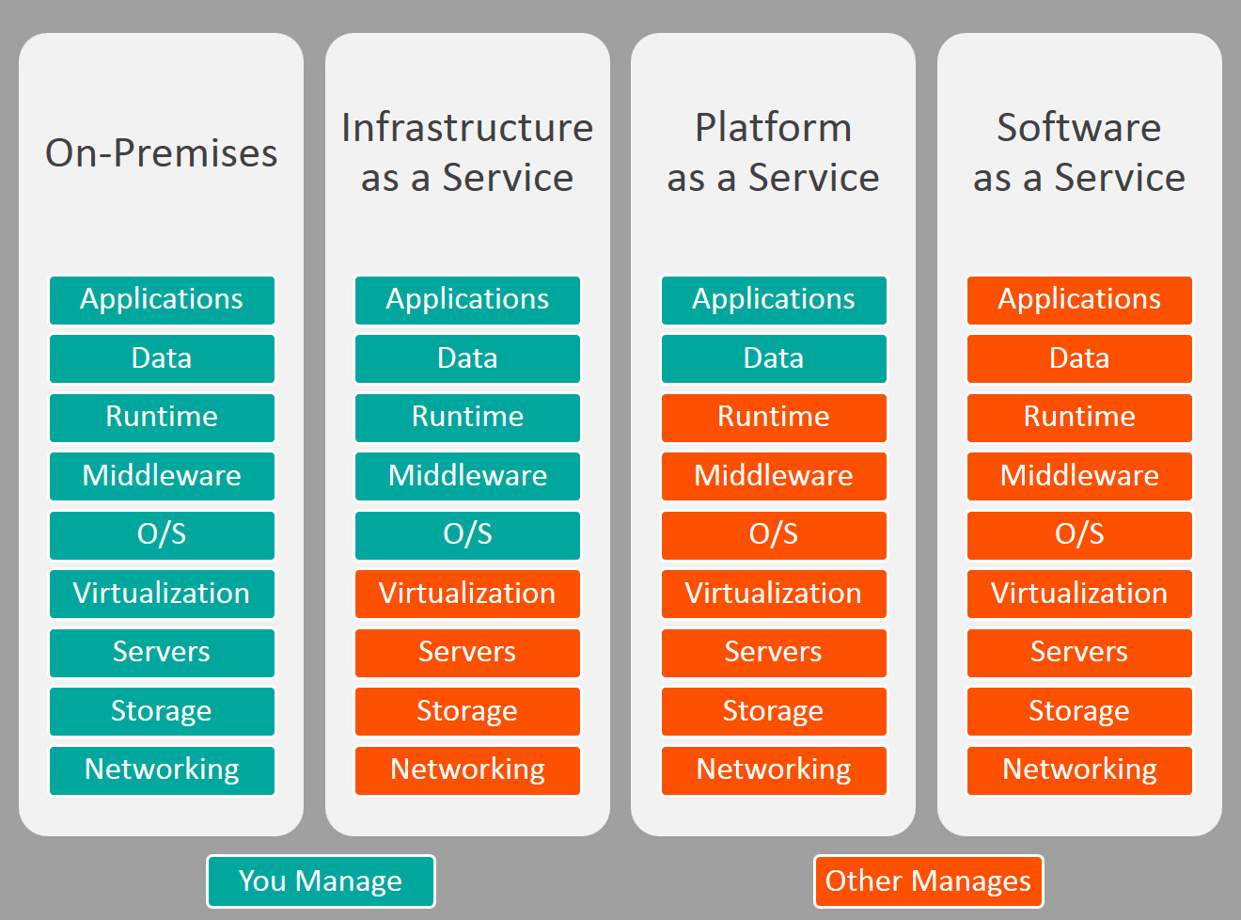

* **Conclusion: Platform-as-a-Service (PaaS) would be the right choice for the ATN company**.
* First, PaaS will provide the whole cycle with fast pace and versatility, it is ideally equipped for corporate data collection. Therefore, this online infrastructure can significantly reduce expenses, enabling it to remove any of the issues that arise as the user rapidly develops and introduces an program.
* Second, PaaS needs less time and management skills, leading to lower TCO from there. Therefore, this cloud service can significantly reduce costs, and it will mitigate some of the issues that exist if you quickly build or delivering a system.
* Lastly, PaaS solutions are generally integrated with authentication and data protection functions, including redundancy mechanisms like replication and backup. This would improve boost protection and raise the need for competences in internal security. PaaS systems may be used to create applications that are ultimately marketed as a service (SaaS) software kit to other users and buyers for certain purposes that render PaaS quite useful for the company.

# References

**There are no sources in the current document.**

[1] Arora, R., Parashar, A. and Transforming, C.C.I., 2013. Secure user data in cloud computing using encryption algorithms. *International journal of engineering research and applications*, *3*(4), pp.1922-1926.

[2] <https://azure.microsoft.com/en-us/overview/what-is-cloud-computing/#cloud-computing-models>

[3] <https://www.bigcommerce.com/blog/saas-vs-paas-vs-iaas/#the-three-types-of-cloud-computing-service-models-explained>